C100固件说明
一、将TF卡装入读卡器，插入电脑，打开“我的电脑”，打开U盘（TF卡格式需为FAT32或exFAT）；
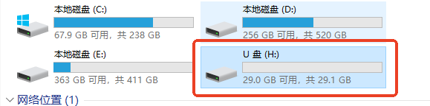
二、将下载好的固件文件放至TF卡初始目录中（根目录）；
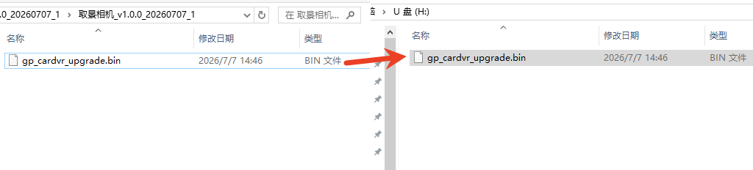
三、将TF卡插入C100，重启C100，指示灯闪烁，开始更新固件；

四、升级过程10秒左右，指示灯停止闪烁并自动关机，固件升级成功。

序号 | 版本号 | 修改内容
1 | V1.1.3 | - 优化部分iPhone手机连接逻辑；  - 增加版本号
2 | V1.1.6 | 1、优化移动设备读取C100照片性能。
注：升级过程中，请勿操作设备或插拔TF卡
版本记录

C100 Firmware Instructions
1. Insert the TF card into a card reader and connect it to your computer. Open "This PC" and then open the removable drive. (The TF card must be formatted as FAT32 or exFAT.)
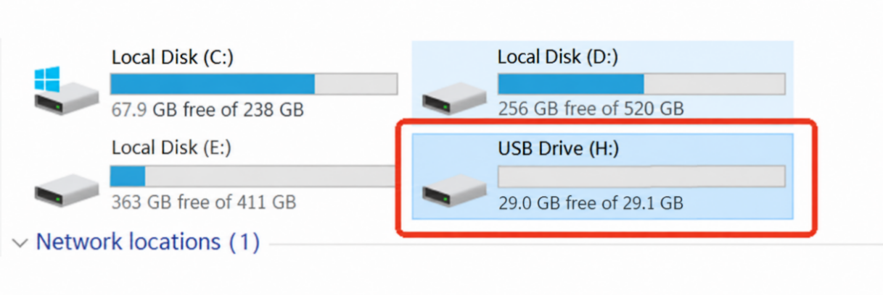
2. Copy the downloaded firmware file to the root directory of the TF card.
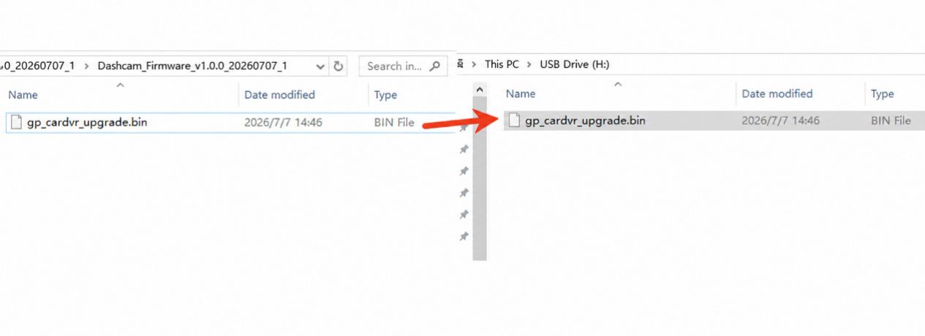
3. Insert the TF card into the C100 and restart the C100. The indicator light will flash, indicating that the firmware update has started.

4. The update takes about 10 seconds. When the indicator light stops flashing and the C100 powers off automatically, the firmware update is complete.

Note: Do not operate the device or insert/remove the TF card during the update.

Version History

No. | Version | What’s news
1 | V1.1.3 | 1. Optimized the connection logic for some iPhone models.  2. Added the version number.
2 | V1.1.6 | 1. Optimize the performance of reading C100 photos on mobile devices.

